**EXPERIMENT # 2**

**DEMONSTRATION OF FOUR**

**STROKE ENGINE**

**OR**

**SPARK IGNITION ENGINE**

* A Four Stroke Engine is an engine which works with four basic steps to a successful rotation of the crankshaft;the intake,compression,power and exhaust stroke.

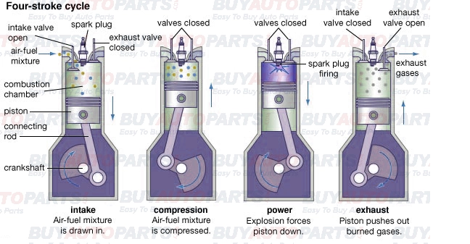**Diagram of Four Stroke Petrol Engine Cycle:**

**Processes:**

There are following processes in Four Stroke Petrol Engine:

* Intake Stroke
* Compression Stroke
* Combustion/Power Stroke
* Exhaust Stroke

**Explanation:**

**Intake Stroke:**

* It is where the intake valves are open and the air is drawn into the cylinder.The fuel injector sprays the fuel into the cylinder to achieve the perfect air-fuel ratio.The downward movement of the piston causes the air and fuel to be sucked into the cylinder.

**Compression Stroke:**

* In this stroke,both the intake and exhaust valves are closed.The upward movement of the piston causes the air-fuel mixture to be compressed upwards towards the spark plug.The compression makes the air and fuel to be sucked into the cylinder.

**Combustion/Power Stroke:**

* During this stroke,both the intake and exhaust valves are still closed.The spark plug produces a spark to ignite the compressed air-fuel mixture.The resulting energy of the combustion forcefully pushes the piston downward.

**Exhaust Stroke:**

* It is the last stroke,when the exhaust valves are open and the exhaust gases are forced up by the resulting piston.

**PARTS LIST**

* Valves(inlet and exhaust)
* Camshaft(controlling the opening and closing of valves)
* Cylinder
* Gudgeon pin
* Crankpin
* Cylinder block
* Crank case
* Crankshaft
* Connecting rod
* Fins in air cooled engines
* Spark plug
* Fuel injectors
* Sump
* Flying wheel
* Piston rings
* Piston

**Brief Description Of The Components**

**Sump:**

* The sump surrounds the crankshaft.It contains some amount of oil,which collects in the bottom of the sump(the oil pan).

**Valves:**

* The intake and exhaust valves open at the proper time to let in air and fuel and to let out exhaust.Note that both valves are closed during compression and combustion so that the combustion chamber is sealed.

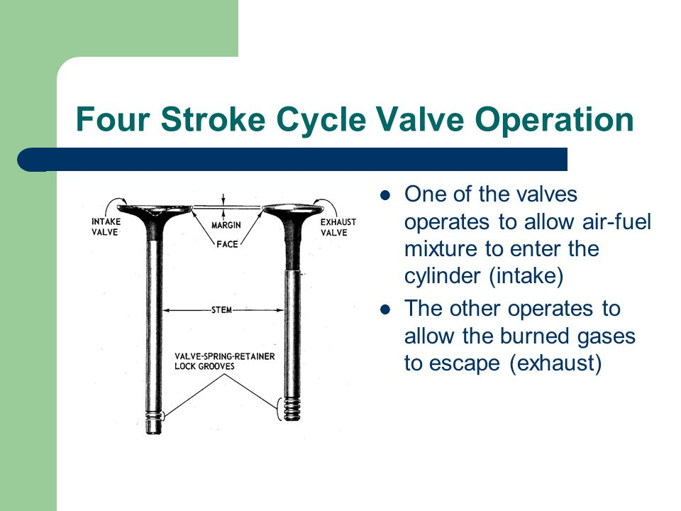

**Flying wheels:**

* A fly wheel is a mechanical device specifically designed to efficiently stores rotational energy.They resist changes in rotational speed by their amount of inertia.The amount of energy stored in a flywheel is proportional to the square of its rotational speed and its mass.
* The flywheel smooths out some of the rpm and force deviation by its resistence to acceleration.

**Fuel injector:**

* Injector,a device for injecting liquid fuel into an internal combustion engine.
* The term is also used to describe an apparatus for injecting feed water into a boiler.

**Gudgeon pin:**

* In four stroke or trunk piston engines,the skirt has arrangements for gudgeon pin,which transmits power from the piston to the gudgeon pin or top end bearing.As there are no cross head guides in four stroke engines,these skirts help in transferring the side thrust produced from the connecting rod to the liner walls.

**CAMshaft:**

* The camshaft is either chain or gear driven from the crankshaft.Because the engine is a four stroke,the camshaft will rotate at half the speed of the crankshaft.(The valves and fuel pump will only operate once for every two revolutions of the crankshaft).

**Figure # 4-1: (figure of CAM shaft)**

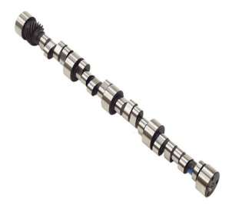

**Cylinder block:**

* The Cylinder block is the basic framework of a car engine.The cylinder block of traditional four stroke engine cannot move and it needs a complicated valve mechanism with large frictional losses and and great noise to finish the working cycle.
* The transmission ratio between crankshaft and cylinder block is 3:1.

**Applications:**

* Petrol cars
* Motorbikes
* Small propeller aircrafts
* Small motor powered boats
* Water spray system

**Disadvantages:**

* It is half as powerful as two stroke engine.
* More expensive
* Complicated design

**Graphical Representation:**

**Graph between pressure and volume:**

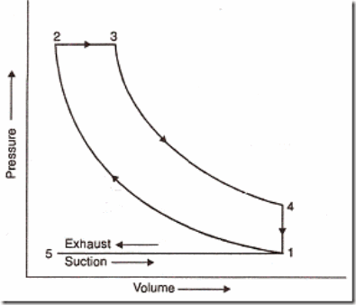

**Graph between temperature and specific entropy:**

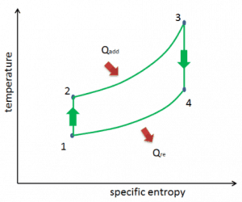

**Difference between Two Stroke Engine**

**and Four Stroke Engine:**

|  |  |
| --- | --- |
| Two Stroke Engine | Four Stroke Engine |
| * It is more powerful. | * It is less powerful. |
| * In two stroke engine,one power stroke is there for every two strokes. | * In four stroke engine,one power stroke is there for every four stroke. |
| * It is less complicated. | * It is more complicated. |
| * It runs less cleaner. | * It runs much cleaner. |
| * It is less expensive. | * It is more expensive. |
| * It has ports for pulling in fuel and air. | * It has intake and exhaust valves rather than ports for pulling in fuel and air. |
| * It produce loud with a high-pitched buzz. | * It produces more of a soft humming noise. |